**Halloween**

1. **toile d’araignée**
2. **araignée**
3. **chaudron**
4. **vampire**
5. **maison hantée**
6. **hibou**
7. **citrouille**
8. **fantôme**
9. **sorcier**
10. **sorcière**
11. **chat noir**
12. **chauve-souris**
13. **monstre**
14. **squelette**
15. **crapaud**
16. **loup**
17. **château**
18. **tombe**
19. **géant**
20. **nain**

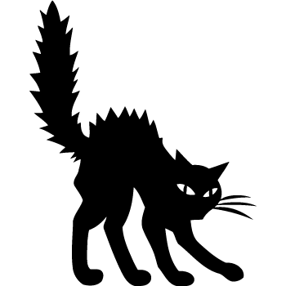   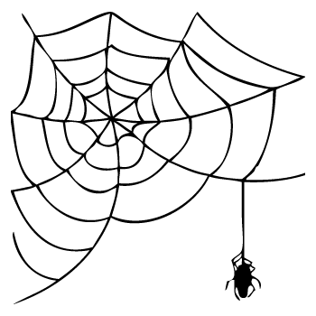 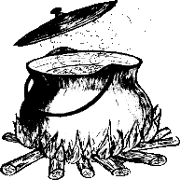 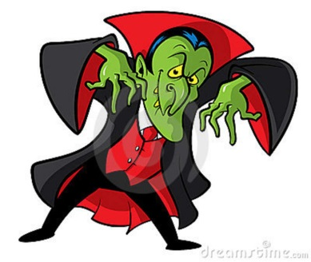 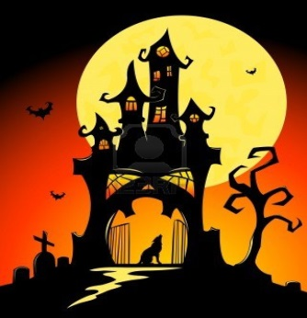  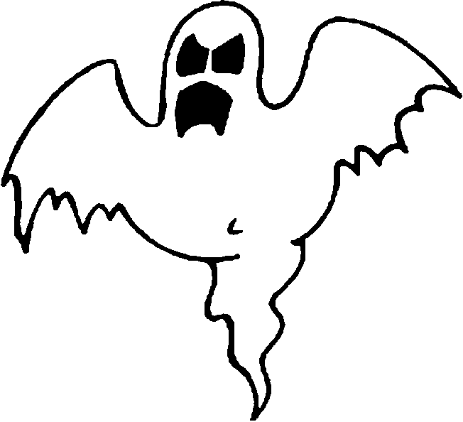 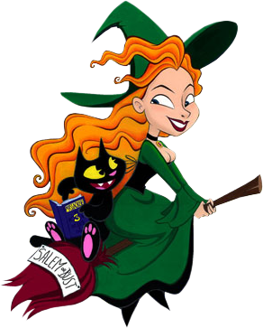 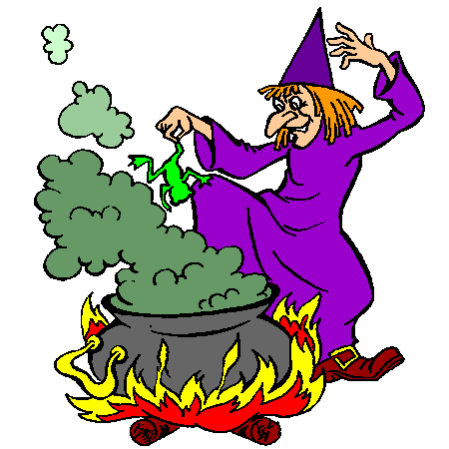 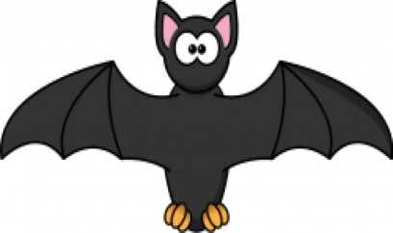

 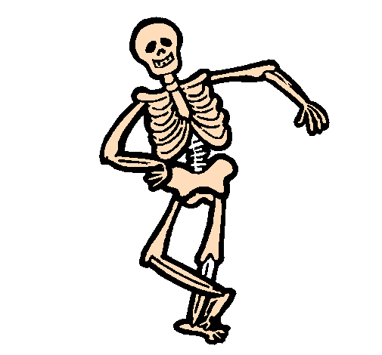 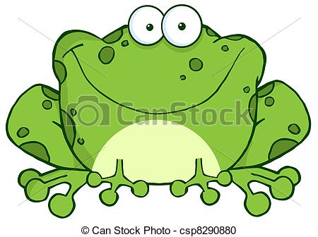 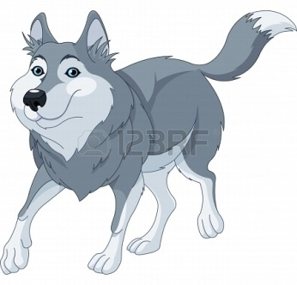

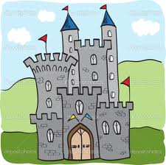 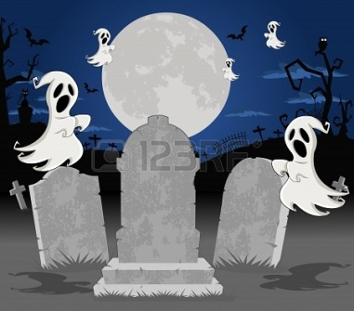 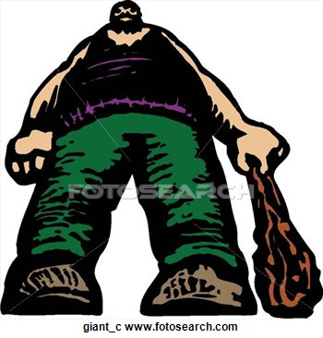 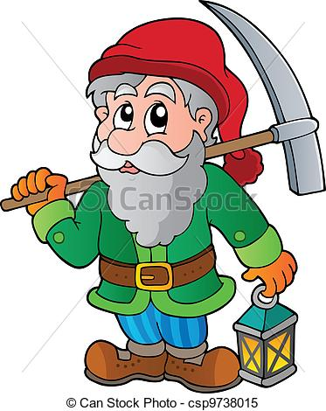

|  |  |  |  |
| --- | --- | --- | --- |
| http://incognitoheureux.i.n.pic.centerblog.net/o/b6149ca9.png | http://us.123rf.com/450wm/denispc/denispc1211/denispc121100049/16375284-halloween-cimetiere-avec-des-tombes-de-fond-et-dessin-anime-drole-personnage-fantome-classique.jpg | http://thumbs.dreamstime.com/z/illustration-de-dessin-anim%C3%A9-de-vampire-de-dracula-11771253.jpg | http://us.123rf.com/450wm/dazdraperma/dazdraperma1305/dazdraperma130500044/19731069-illustration-o-mignon-dessin-anime-loup-courir.jpg |
| http://www.lezebre.lu/images/Toile_Araignee.png |  | http://thumbs.dreamstime.com/z/hibou-noir-de-dessin-anim%C3%A9-7287647.jpg | http://us.123rf.com/400wm/400/400/amalga/amalga1109/amalga110900018/10569755-chateau-de-halloween-noir-et-de-la-lune-illustration-de-dessin-vectoriel.jpg |
| http://coloriage.estaticos.net/dessins/peindre/201136/5e5df53383f2921c0260880154adedcf.png | http://www.mescoloriages.com/coloriages/halloween/fantomes/page%203/images/fantome43.gif |  | http://kivagottkepek.lapunk.hu/tarhely/kivagottkepek/kepek/2halloween_salemorbust_ppsz.png |
| http://static.freepik.com/photos-libre/chauve-souris-de-dessin-anime_17-1211161211.jpg | http://comps.canstockphoto.com/can-stock-photo_csp8290880.jpg | http://ekladata.com/8HSWdjfVb08w9Lane-uv_xgda2U.gif | https://encrypted-tbn2.gstatic.com/images?q=tbn:ANd9GcSDjy7zfMKln_07kI92C6cGSb-sm4-Q8hs9Wr-rZZcExHqhcUHW |

|  |  |  |  |  |  |  |  |
| --- | --- | --- | --- | --- | --- | --- | --- |
| http://us.123rf.com/450wm/denispc/denispc1211/denispc121100049/16375284-halloween-cimetiere-avec-des-tombes-de-fond-et-dessin-anime-drole-personnage-fantome-classique.jpg |  | | http://www.mescoloriages.com/coloriages/halloween/fantomes/page%203/images/fantome43.gif | | | http://coloriage.estaticos.net/dessins/peindre/201136/5e5df53383f2921c0260880154adedcf.png | |
| http://thumbs.dreamstime.com/z/hibou-noir-de-dessin-anim%C3%A9-7287647.jpg |  | | http://static.freepik.com/photos-libre/chauve-souris-de-dessin-anime_17-1211161211.jpg | | | http://comps.canstockphoto.com/can-stock-photo_csp8290880.jpg | |
| http://www.lezebre.lu/images/Toile_Araignee.png | http://us.123rf.com/400wm/400/400/amalga/amalga1109/amalga110900018/10569755-chateau-de-halloween-noir-et-de-la-lune-illustration-de-dessin-vectoriel.jpg | | http://us.123rf.com/450wm/dazdraperma/dazdraperma1305/dazdraperma130500044/19731069-illustration-o-mignon-dessin-anime-loup-courir.jpg | | | http://thumbs.dreamstime.com/z/illustration-de-dessin-anim%C3%A9-de-vampire-de-dracula-11771253.jpg | |
| https://encrypted-tbn2.gstatic.com/images?q=tbn:ANd9GcSDjy7zfMKln_07kI92C6cGSb-sm4-Q8hs9Wr-rZZcExHqhcUHW | http://ekladata.com/8HSWdjfVb08w9Lane-uv_xgda2U.gif | | http://comps.canstockphoto.com/can-stock-photo_csp9738015.jpg | | | http://ec.l.thumbs.canstockphoto.com/canstock5642324.jpg | |
| http://comps.fotosearch.com/comp/ARP/ARP123/geant_%7Egiant_c.jpg | | http://www.lezebre.lu/images/Toile_Araignee.png | | http://us.123rf.com/400wm/400/400/amalga/amalga1109/amalga110900018/10569755-chateau-de-halloween-noir-et-de-la-lune-illustration-de-dessin-vectoriel.jpg | http://thumbs.dreamstime.com/z/hibou-noir-de-dessin-anim%C3%A9-7287647.jpg | |
| http://thumbs.dreamstime.com/z/illustration-de-dessin-anim%C3%A9-de-vampire-de-dracula-11771253.jpg | | http://us.123rf.com/450wm/dazdraperma/dazdraperma1305/dazdraperma130500044/19731069-illustration-o-mignon-dessin-anime-loup-courir.jpg | | http://coloriage.estaticos.net/dessins/peindre/201136/5e5df53383f2921c0260880154adedcf.png | http://www.mescoloriages.com/coloriages/halloween/fantomes/page%203/images/fantome43.gif | |
| http://kivagottkepek.lapunk.hu/tarhely/kivagottkepek/kepek/2halloween_salemorbust_ppsz.png | |  | | http://static.freepik.com/photos-libre/chauve-souris-de-dessin-anime_17-1211161211.jpg | http://ec.l.thumbs.canstockphoto.com/canstock5642324.jpg | |
| http://comps.canstockphoto.com/can-stock-photo_csp8290880.jpg | | http://www.coloriage.tv/dessincolo/de-sorciere.png | | http://incognitoheureux.i.n.pic.centerblog.net/o/b6149ca9.png |  | |

|  |  |  |  |
| --- | --- | --- | --- |
| http://www.lezebre.lu/images/Toile_Araignee.png | http://comps.canstockphoto.com/can-stock-photo_csp9738015.jpg | http://us.123rf.com/450wm/dazdraperma/dazdraperma1305/dazdraperma130500044/19731069-illustration-o-mignon-dessin-anime-loup-courir.jpg | http://thumbs.dreamstime.com/z/hibou-noir-de-dessin-anim%C3%A9-7287647.jpg |
| http://thumbs.dreamstime.com/z/illustration-de-dessin-anim%C3%A9-de-vampire-de-dracula-11771253.jpg |  | http://us.123rf.com/400wm/400/400/amalga/amalga1109/amalga110900018/10569755-chateau-de-halloween-noir-et-de-la-lune-illustration-de-dessin-vectoriel.jpg | http://coloriage.estaticos.net/dessins/peindre/201136/5e5df53383f2921c0260880154adedcf.png |
| http://kivagottkepek.lapunk.hu/tarhely/kivagottkepek/kepek/2halloween_salemorbust_ppsz.png | http://incognitoheureux.i.n.pic.centerblog.net/o/b6149ca9.png | http://static.freepik.com/photos-libre/chauve-souris-de-dessin-anime_17-1211161211.jpg | http://www.mescoloriages.com/coloriages/halloween/fantomes/page%203/images/fantome43.gif |
| http://ekladata.com/8HSWdjfVb08w9Lane-uv_xgda2U.gif | https://encrypted-tbn2.gstatic.com/images?q=tbn:ANd9GcSDjy7zfMKln_07kI92C6cGSb-sm4-Q8hs9Wr-rZZcExHqhcUHW | http://comps.canstockphoto.com/can-stock-photo_csp8290880.jpg | http://www.coloriage.tv/dessincolo/de-sorciere.png |